飯店訂房系統對應的SQL Server資料庫_匯入CSV

--建立飯店管理資料庫

CREATE DATABASE HotelManagement;

GO

USE HotelManagement;

--建立飯店訂房表格

CREATE TABLE Reservations (

ReservationID INT IDENTITY(1,1) PRIMARY KEY,

CustomerName NVARCHAR(100) NOT NULL,

RoomType NVARCHAR(50) NOT NULL,

CheckInDate DATE NOT NULL,

Status NVARCHAR(20) DEFAULT 'Active' -- (Active, Cancelled)

);

BULK INSERT Reservations

FROM 'D:\import\Reservations.csv'

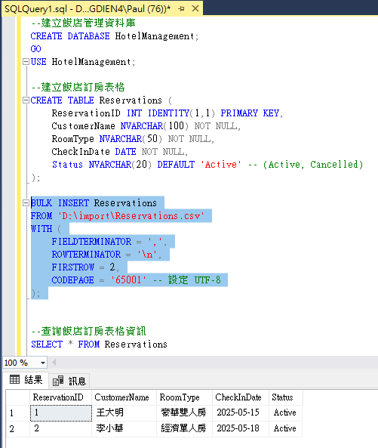WITH (

FIELDTERMINATOR = ',',

ROWTERMINATOR = '\n',

FIRSTROW = 2,

CODEPAGE = '65001' -- 設定 UTF-8

);